<!DOCTYPE html>

<html>

    <head>

        <tittle>

             Forms:

        </tittle>

        <br><br>

    </head>

    <body>

        <form action="/action_page.php" autocomplete="on">

            <label for="fname">First name:</label>

            <input type="text" id="fname" value="Gnanadeepam">

            <br><br>

            <label for="lname">Last name:</label>

            <input type="text" id="text" value="Bharathi">

            <br><br>

            <label for="pwd">Password:</label>

            <input type="pasword" id="pwd" name="pwd" minlength="8">

            <br><br>

            <label for="email">Email:</label>

            <input type="email" id=email name="email">

            <br><br>

            <label for="phone">Enter a phone number:</label><br><br>

            <input type="tel" id="phone" name="phone" placeholder="123-45-678" pattern="[0-9]{3}-[0-9]{2}-[0-9]{3}" required>

            <br><br>

            <label for="birthday">Birthday:</label>

            <input type="date" id="birthday" name="birthday">

            <br><br>

            <input type="radio" id="html" name="fav_language" value="HTML">

            <label for="html">HTML</label><br>

            <input type="radio" id="css" name="fav_language" value="CSS"

            <label for="css">CSS</label>

            <br>

            <input type="radio" id="javascript" name="fav_language" Value="Javascript">

            <label for="javascript">Javascript</label>

            <br><br>

            <p>Click on the "Choose File" button to upload a file:</p>

            <input type="file" id="myFile" name="filename">

            <br><br>

            <input type="submit" value="Submit">

            <input type="reset" value="Reset">

        </form>

        <p>If you click the "Submit"  button, the form-data will be sent to a page called "/action_page.php".</p>

    </body>

</html>

**OUTPUT:**

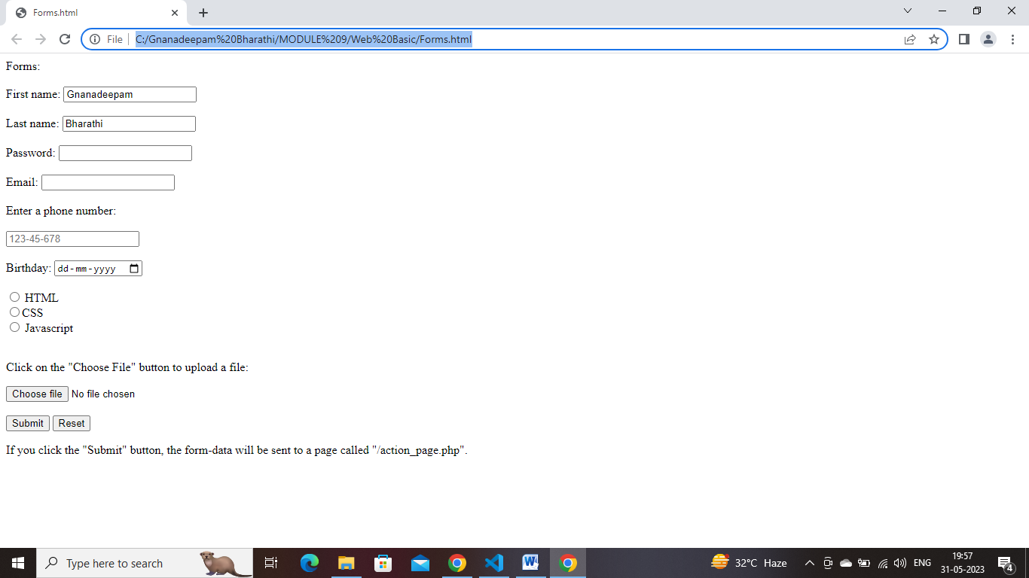

<!DOCCTYPE html>

<html>

    <head>

        <tittle>Forms Elements:</tittle>

    </head>

    <body>

        <!-- Header tag -->

        <h1> 1.HEADER TAG: </h1>

        <article>

            <header>

               <h1> A heading here </h1>

               <p> Posted by Gnanadeepam Bharathi </p>

               <p> Some additional information here</p>

            </header>

            <p> Three Little Monkeys Jumping On The Bed </p>

        </article><hr>

        <!-- Footer tag -->

        <h2> 2.FOOTER TAG: </h2>

        <footer>

            <p> Thanks & Regards<br>

            Gnanadeepam Bharathi<br>

            <a href="mailto:gnanadeepam2000@gmail.com">gnanadeepam2000@gmail.com</a></p>

        </footer><hr>

        <!-- Navigation tag -->

        <h3> 3.NAVIGATION TAG: </h3>

        <nav>

            <a href="/Java/">Java</a> |

            <a href="/Python/">Python</a> |

            <a href="/C Programming/">C Programming</a> |

            <a href="/C++/">C++</a>

        </nav><hr>

        <!-- aside tag -->

        <h4> 4.ASIDE TAG: </h4>

        <style>

            aside {

                padding-right: 200px;

                font: italic;

                background-color: violet;

                font-size: medium;

            }

        </style>

        <p> Pets are a great blessing in anyone's life.They are the only ones who love us unconditionally. Pets always offer us everything they have without asking for anything in return. </p>

        <p> This is how the relationship between pets is evolving. People treat them no less than humans. For instance, they celebrate their birthdays; get those matching outfits and more. </p>

        <aside>

            <img src="C:\Users\Admin\Desktop\little-cute-maltipoo-puppy-royalty-free-image-1652926025.jpg" width="150" height="150" alt="The picture of dog">

            <p> My father adopted Sasha when he was a little baby. His friend had given birth to puppies and they decided to put the puppies up for adoption. We convinced our father to get one for us. Considering they knew our family well, they immediately agreed. Little did we know that our lives would change forever after his entrance. </p>

        </aside>

        <p> This is how the relationship between pets is evolving. People treat them no less than humans. For instance, they celebrate their birthdays; get those matching outfits and more. </p><hr>

        <!-- Meter tag -->

        <h5> 5.METER TAG: </h5>

        <h5> Ratings for programming languages: </h5>

        <label for="java">Java:</label>

        <meter id="java" value="30" min="0" max="100"></meter><br>

        <label for="html">HTML:</label>

        <meter id="html" value="75" min="0" max="100"></meter><br>

        <label for="python">Python:</label>

        <meter id="python" value="50" min="0" max="100"></meter><hr>

        <!-- section tag -->

        <h6> 6.SECTION TAG: </h6>

        <section>

            <h1>WWF</h1>

            <p>The World Wide Fund for Nature (WWF) is an international organization working on issues regarding the conservation, research and restoration of the environment, formerly named the World Wildlife Fund. WWF was founded in 1961.</p>

          </section>

          <section>

            <h1>WWF's Panda symbol</h1>

            <p>The Panda has become the symbol of WWF. The well-known panda logo of WWF originated from a panda named Chi Chi that was transferred from the Beijing Zoo to the London Zoo in the same year of the establishment of WWF.</p>

          </section><hr>

          <!-- Article tag -->

          <h7> 7.ARTICLE TAG: </h7>

          <article>

            <h2>Google Chrome</h2>

            <p>Google Chrome is a web browser developed by Google, released in 2008. Chrome is the world's most popular web browser today!</p>

          </article>

          <article>

            <h2>Mozilla Firefox</h2>

            <p>Mozilla Firefox is an open-source web browser developed by Mozilla. Firefox has been the second most popular web browser since January, 2018.</p>

          </article>

          <article>

            <h2>Microsoft Edge</h2>

            <p>Microsoft Edge is a web browser developed by Microsoft, released in 2015. Microsoft Edge replaced Internet Explorer.</p>

          </article><hr>

          <!-- video tag -->

          <h8> 8.VIDEO TAG: </h8>

          <video width="150" heigth="150" controls>

            <source src="C:\Users\Admin\Downloads\pexels-fuzail-ahmad-3324489-1080x1920-30fps.mp4" type="video/mp4">

            Your browser does not support the video tag.

          </video><hr>

          <!-- Audio tag -->

          <h9> 9.AUDIO TAG: </h9>

          <audio controls>

            <source src="C:\Users\Admin\Downloads\birds-19624.mp3" type="audio/mpeg">

            Your browser does not support the audio tag.

          </audio><hr>

          <!-- iframe tag -->

          <h10> 10.i FRAME TAG: </h10>

          <iframe src="https://www.youtube.com/embed/6BBueFDTJ3o" width="420" height="345"></iframe><hr>

  </body>

</html>

**OUTPUT:**

# C:\Users\Admin\Pictures\Screenshots\Screenshot (61).png

# C:\Users\Admin\Pictures\Screenshots\Screenshot (62).png

# C:\Users\Admin\Pictures\Screenshots\Screenshot (63).png

# C:\Users\Admin\Pictures\Screenshots\Screenshot (65).png